INTERMEDIATE LEVEL
11.Write a java program that shows the application of constructors.
Source code
class Student {
String name;
int age;
Student() {
name = "Unknown";
age = 0;
System.out.println("Default constructor called!");
}
Student(String n, int a) {
name = n;
age = a;
System.out.println("Parameterized constructor called!");
}
void display() {
System.out.println("Name: " + name + ", Age: " + age);
}
public static void main(String[] args) {
Student s1 = new Student();
s1.display();
System.out.println();
Student s2 = new Student("Shreya", 21);
s2.display();
}
}
Output

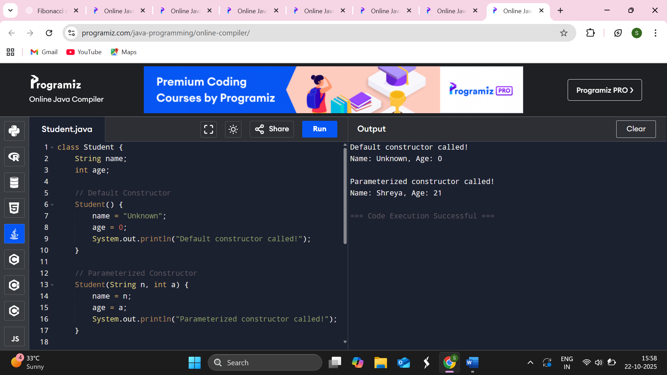
12.Write a java program to find the electricity bill using inheritance.
Source code
import java.util.Scanner;
class Customer {
protected String name;
protected int units;
public Customer(String name, int units) {
this.name = name;
this.units = units;
}
public void displayCustomerInfo() {
System.out.println("Customer Name: " + name);
System.out.println("Units Consumed: " + units);
}
public double calculateBill() {
return 0;
}
}
class Domestic extends Customer {
public Domestic(String name, int units) {
super(name, units);
}
public double calculateBill() {
double bill;
if (units <= 100) {
bill = units * 5;
} else if (units <= 200) {
bill = 100 * 5 + (units - 100) * 7;
} else {
bill = 100 * 5 + 100 * 7 + (units - 200) * 10;
}
return bill;
}
}
class Commercial extends Customer {
public Commercial(String name, int units) {
super(name, units);
}
public double calculateBill() {
double bill;
if (units <= 100) {
bill = units * 10;
} else if (units <= 200) {
bill = 100 * 10 + (units - 100) * 15;
} else {
bill = 100 * 10 + 100 * 15 + (units - 200) * 20;
}
return bill;
}
}
public class ElectricityBill {
public static void main(String[] args) {
Scanner sc = new Scanner(System.in);
System.out.print("Enter customer name: ");
String name = sc.nextLine();
System.out.print("Enter units consumed: ");
int units = sc.nextInt();
System.out.print("Enter type (1-Domestic, 2-Commercial): ");
int type = sc.nextInt();
Customer customer;
if (type == 1) {
customer = new Domestic(name, units);
} else {
customer = new Commercial(name, units);
}
customer.displayCustomerInfo();
System.out.println("Electricity Bill: Rs. " + customer.calculateBill());
sc.close();
}
}
Output
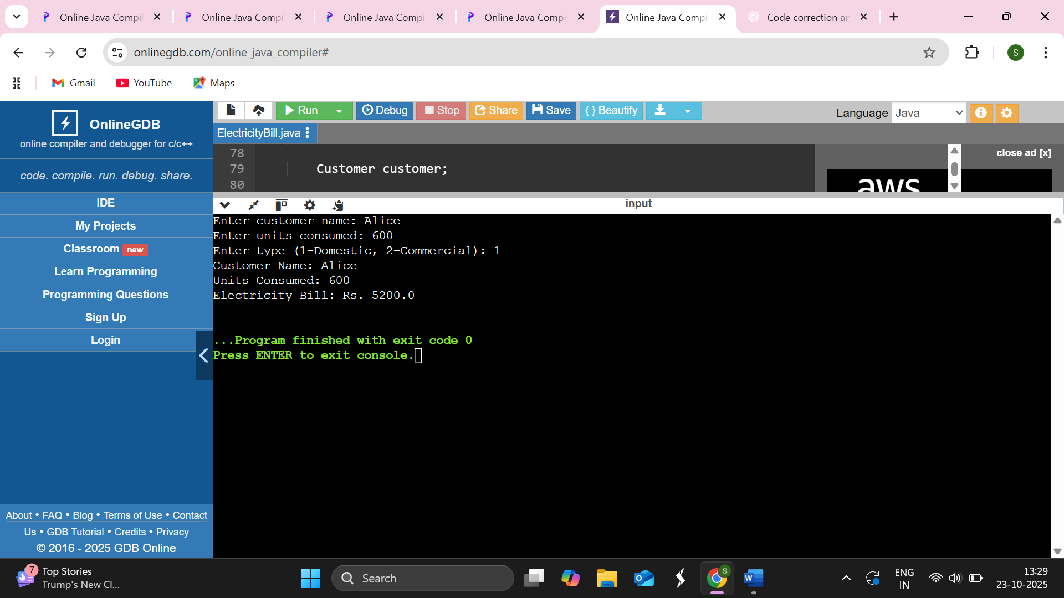

13.Create a class “Vehicle” with instance variable vehicle_type. Inherit the class in a class called “Car” with instance model_type, company name etc. Display the information of the vehicle by defining the display() in both super and sub class.
Source code
class Vehicle {
protected String vehicle_type;
public Vehicle(String vehicle_type) {
this.vehicle_type = vehicle_type;
}
public void display() {
System.out.println("Vehicle Type: " + vehicle_type);
}
}
class Car extends Vehicle {
private String model_type;
private String company_name;
public Car(String vehicle_type, String model_type, String company_name) {
super(vehicle_type);
this.model_type = model_type;
this.company_name = company_name;
}
public void display() {
super.display(); // Call display() of Vehicle class
System.out.println("Car Model Type: " + model_type);
System.out.println("Company Name: " + company_name);
}
}
public class VehicleDemo {
public static void main(String[] args) {
Vehicle v = new Vehicle("Two-Wheeler");
v.display();
System.out.println("--------------------------");
Car c = new Car("Four-Wheeler", "Sedan", "Toyota");
c.display();
}
}
Output
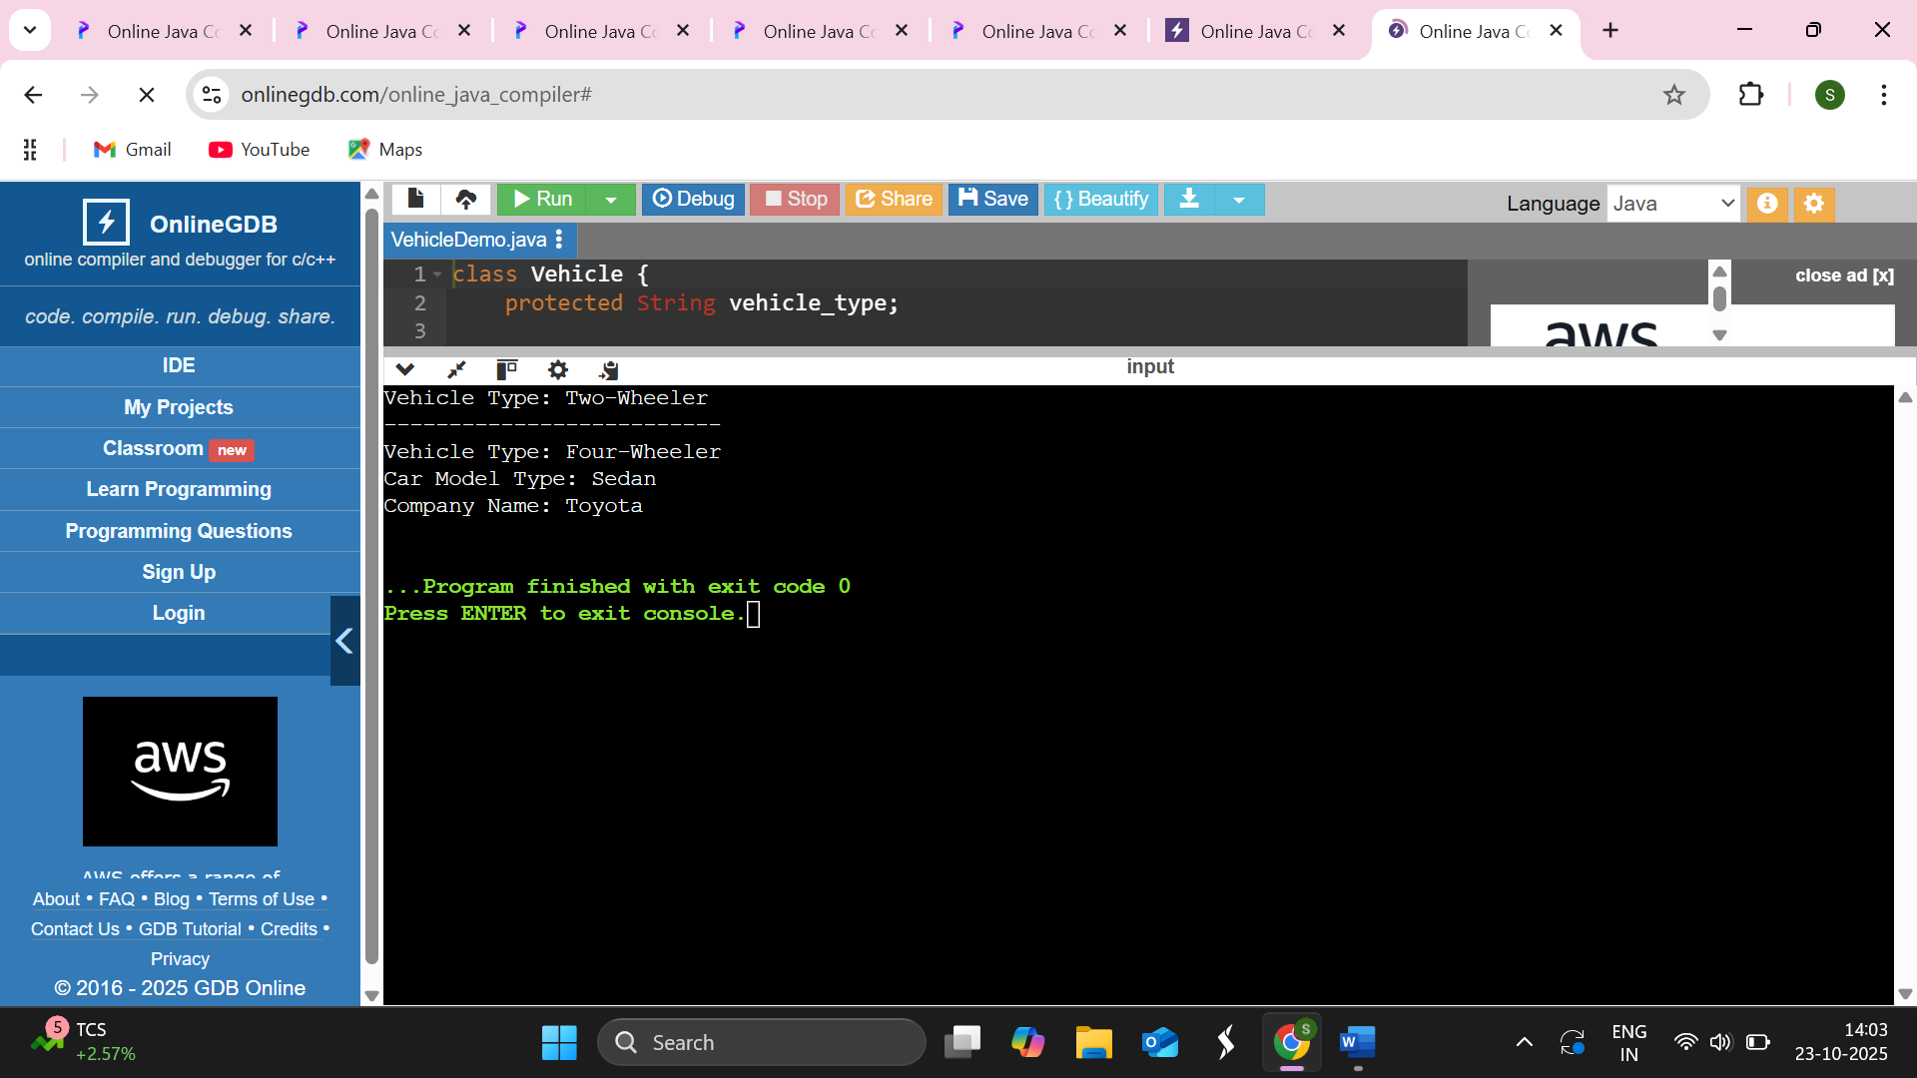

14.Create a class “Account” containing account No, and balance as an instance variable. Derive the Account class into two classes names “Savings” and “Current”. The Savings class should contain instance variable named interest rate, and the “Current” class should contain instance variable named interest rate, and the “Current” class should contain instance variable called overdraft limit. Define appropriate methods for all the classes to enable functionalities to check balance, deposit, and withdraw amount in Savings and Current account.
Source code
class Account {
protected int accountNumber;
protected double balance;
public Account(int accountNumber, double balance) {
this.accountNumber = accountNumber;
this.balance = balance;
}
public void deposit(double amount) {
if (amount > 0) {
balance += amount;
System.out.println("Deposited: " + amount);
} else {
System.out.println("Invalid deposit amount!");
}
}
public void withdraw(double amount) {
if (amount > 0 && amount <= balance) {
balance -= amount;
System.out.println("Withdrawn: " + amount);
} else {
System.out.println("Insufficient balance or invalid amount!");
}
}
public void checkBalance() {
System.out.println("Account Number: " + accountNumber + ", Current Balance: " + balance);
}
}
class Savings extends Account {
private double interestRate;

public Savings(int accountNumber, double balance, double interestRate) {
super(accountNumber, balance);
this.interestRate = interestRate;
}
public void addInterest() {
double interest = balance * interestRate / 100;
balance += interest;
System.out.println("Interest added: " + interest);
}
public void checkBalance() {
System.out.println("Savings Account Balance: " + balance);
}
}
class Current extends Account {
private double overDraftLimit;
public Current(int accountNumber, double balance, double overDraftLimit) {
super(accountNumber, balance);
this.overDraftLimit = overDraftLimit;
}
public void withdraw(double amount) {
if (amount <= balance + overDraftLimit) {
balance -= amount;
System.out.println("Withdrawn: " + amount);
} else {
System.out.println("Withdrawal exceeds overdraft limit!");
}
}
public void checkBalance() {
System.out.println("Current Account Balance: " + balance);
}
}
public class BankDemo {
public static void main(String[] args) {
Savings s = new Savings(1001, 5000, 5.0);
s.checkBalance();
s.deposit(1000);
s.addInterest();
s.withdraw(2000);
s.checkBalance();
System.out.println("---------------------------");
Current c = new Current(2001, 3000, 1000);
c.checkBalance();
c.deposit(1500);
c.withdraw(4000);
c.checkBalance();
c.withdraw(1000);
}
}
Output
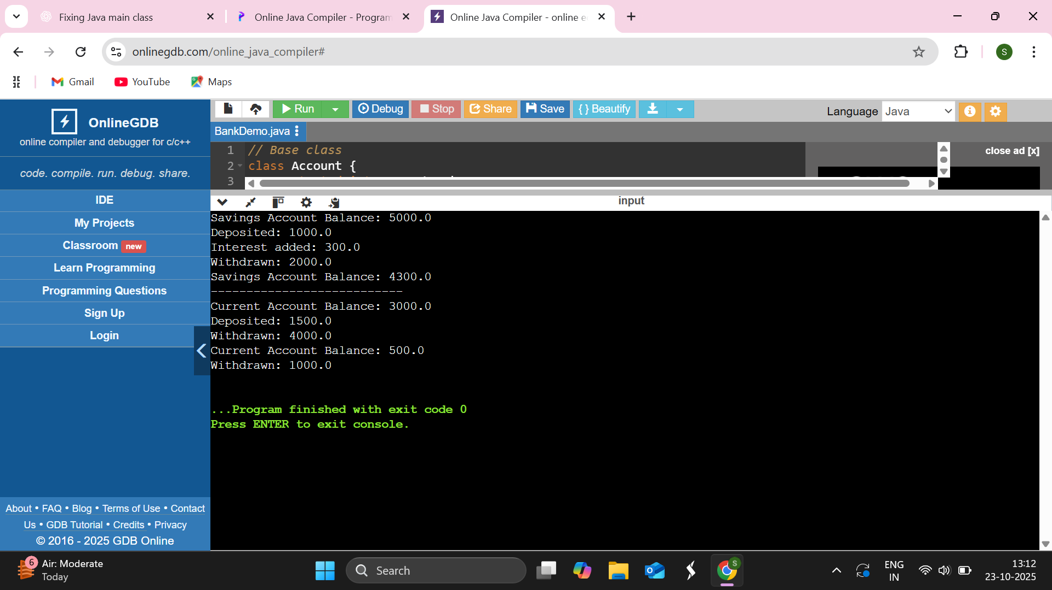

15.Write a java program to demonstrate the use of ‘this’ and ‘static’ keyword.
Source code
class Student {
String name;
int age;
static String college = "ABC University";
Student(String name, int age) {
this.name = name;
this.age = age;
}
void display() {
System.out.println("Name: " + this.name);
System.out.println("Age: " + this.age);
System.out.println("College: " + college);
System.out.println("----------------------");
}
static void changeCollege(String newCollege) {
college = newCollege;
}
}
public class ThisAndStaticDemo {
public static void main(String[] args) {
Student s1 = new Student("Alice", 20);
Student s2 = new Student("Bob", 22);
s1.display();
s2.display();
Student.changeCollege("XYZ Institute");
s1.display();
s2.display();
}
}
Output
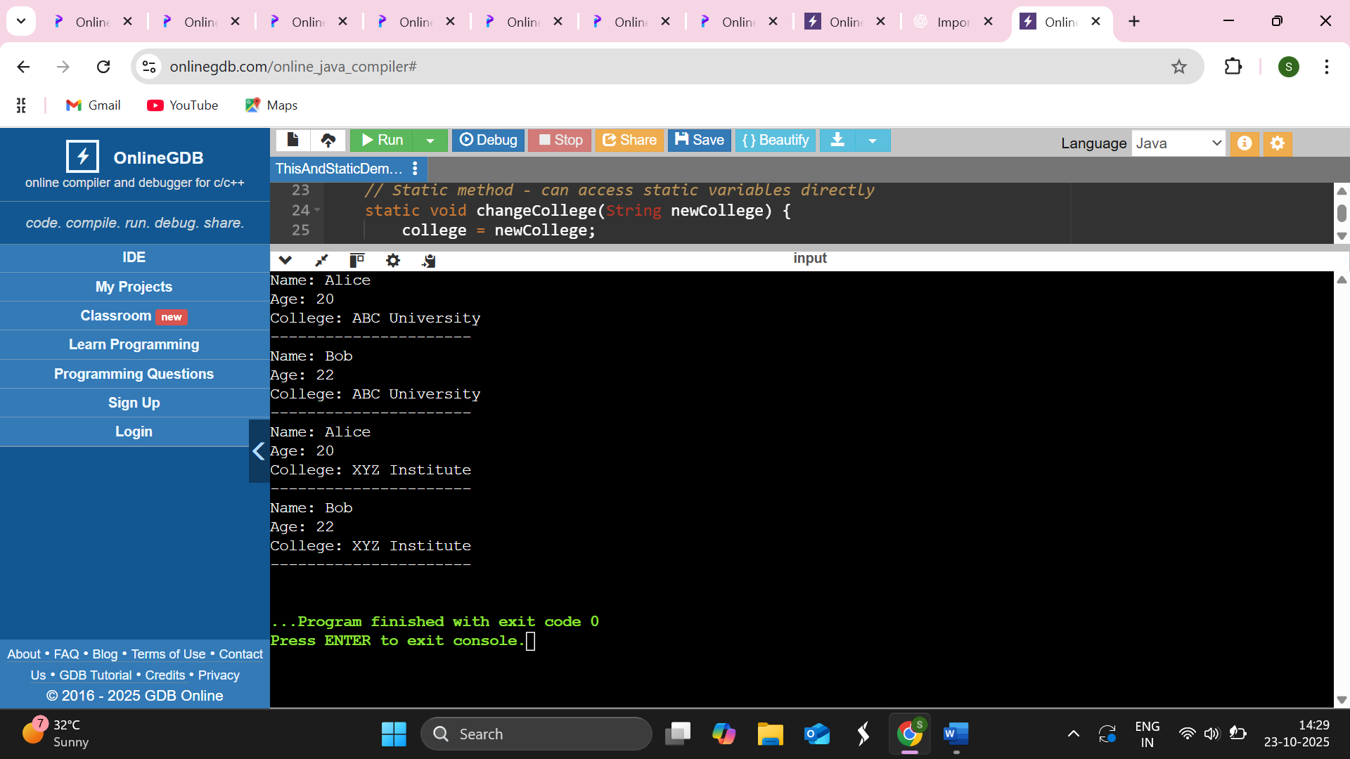
16.Describe abstract class called Shape, which has three subclasses, say Triangle, Rectangle, and Circle. Define one method area in the abstract class and override its area in these three subclasses to calculate for specific object, i.e., area of Triangle. Subclass should calculate area of Triangle, etc. Same for Rectangle and Circle using Java.
Source code
abstract class Shape{
abstract double area();
}
class Triangle extends Shape {
private double base, height;
public Triangle(double base, double height) {
this.base = base;
this.height = height;
}
double area() {
return 0.5 * base * height;
}
}
class Rectangle extends Shape {
private double length, width;
public Rectangle(double length, double width) {
this.length = length;
this.width = width;
}
double area() {
return length * width;
}
}
class Circle extends Shape {
private double radius;

public Circle(double radius) {
this.radius = radius;
}
double area() {
return Math.PI * radius * radius;
}
}
public class ShapeDemo {
public static void main(String[] args) {
// Create objects of each subclass
Shape triangle = new Triangle(5, 8);
Shape rectangle = new Rectangle(6, 4);
Shape circle = new Circle(3);
System.out.println("Area of Triangle: " + triangle.area());
System.out.println("Area of Rectangle: " + rectangle.area());
System.out.println("Area of Circle: " + circle.area());
}
}
Output
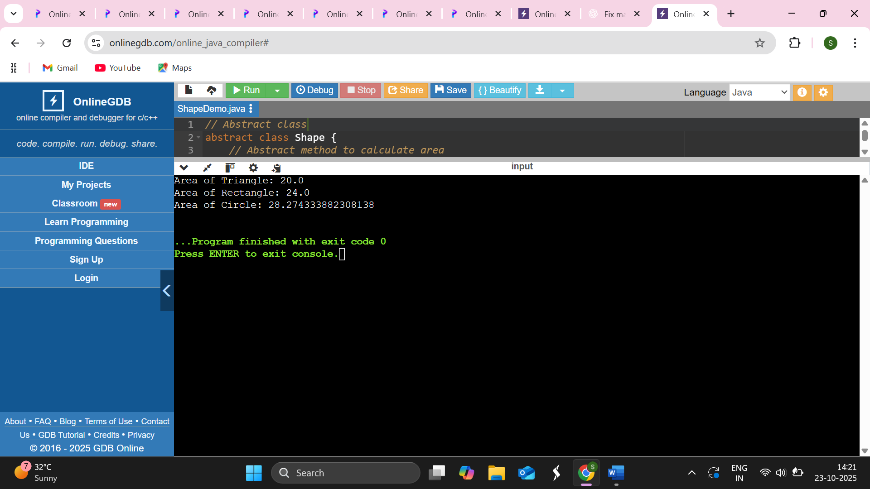

17.Write a Java program to find the result sheet of a student using interfaces.
Source code
interface Student {
void getDetails(String name, int rollNo);
}
interface Marks {
void getMarks(int m1, int m2, int m3);
}
interface Result {
void calculateResult();
}
class ResultSheet implements Student, Marks, Result {
String name;
int rollNo;
int m1, m2, m3;
double total, average;
String grade;
public void getDetails(String name, int rollNo) {
this.name = name;
this.rollNo = rollNo;
}
public void getMarks(int m1, int m2, int m3) {
this.m1 = m1;
this.m2 = m2;
this.m3 = m3;
}
public void calculateResult() {
total = m1 + m2 + m3;
average = total / 3.0;
if (average >= 90) {
grade = "A+";
} else if (average >= 75) {
grade = "A";
} else if (average >= 60) {
grade = "B";
} else if (average >= 40) {
grade = "C";
} else {
grade = "Fail";
}
System.out.println("----- STUDENT RESULT SHEET -----");
System.out.println("Name: " + name);
System.out.println("Roll No: " + rollNo);
System.out.println("Marks: " + m1 + ", " + m2 + ", " + m3);
System.out.println("Total: " + total);
System.out.println("Average: " + average);
System.out.println("Grade: " + grade);
System.out.println("--------------------------------");
}
}
public class StudentResult {
public static void main(String[] args) {
ResultSheet rs = new ResultSheet();
rs.getDetails("Shreya Prakash", 101);
rs.getMarks(85, 90, 80);
rs.calculateResult();
}
}

Output
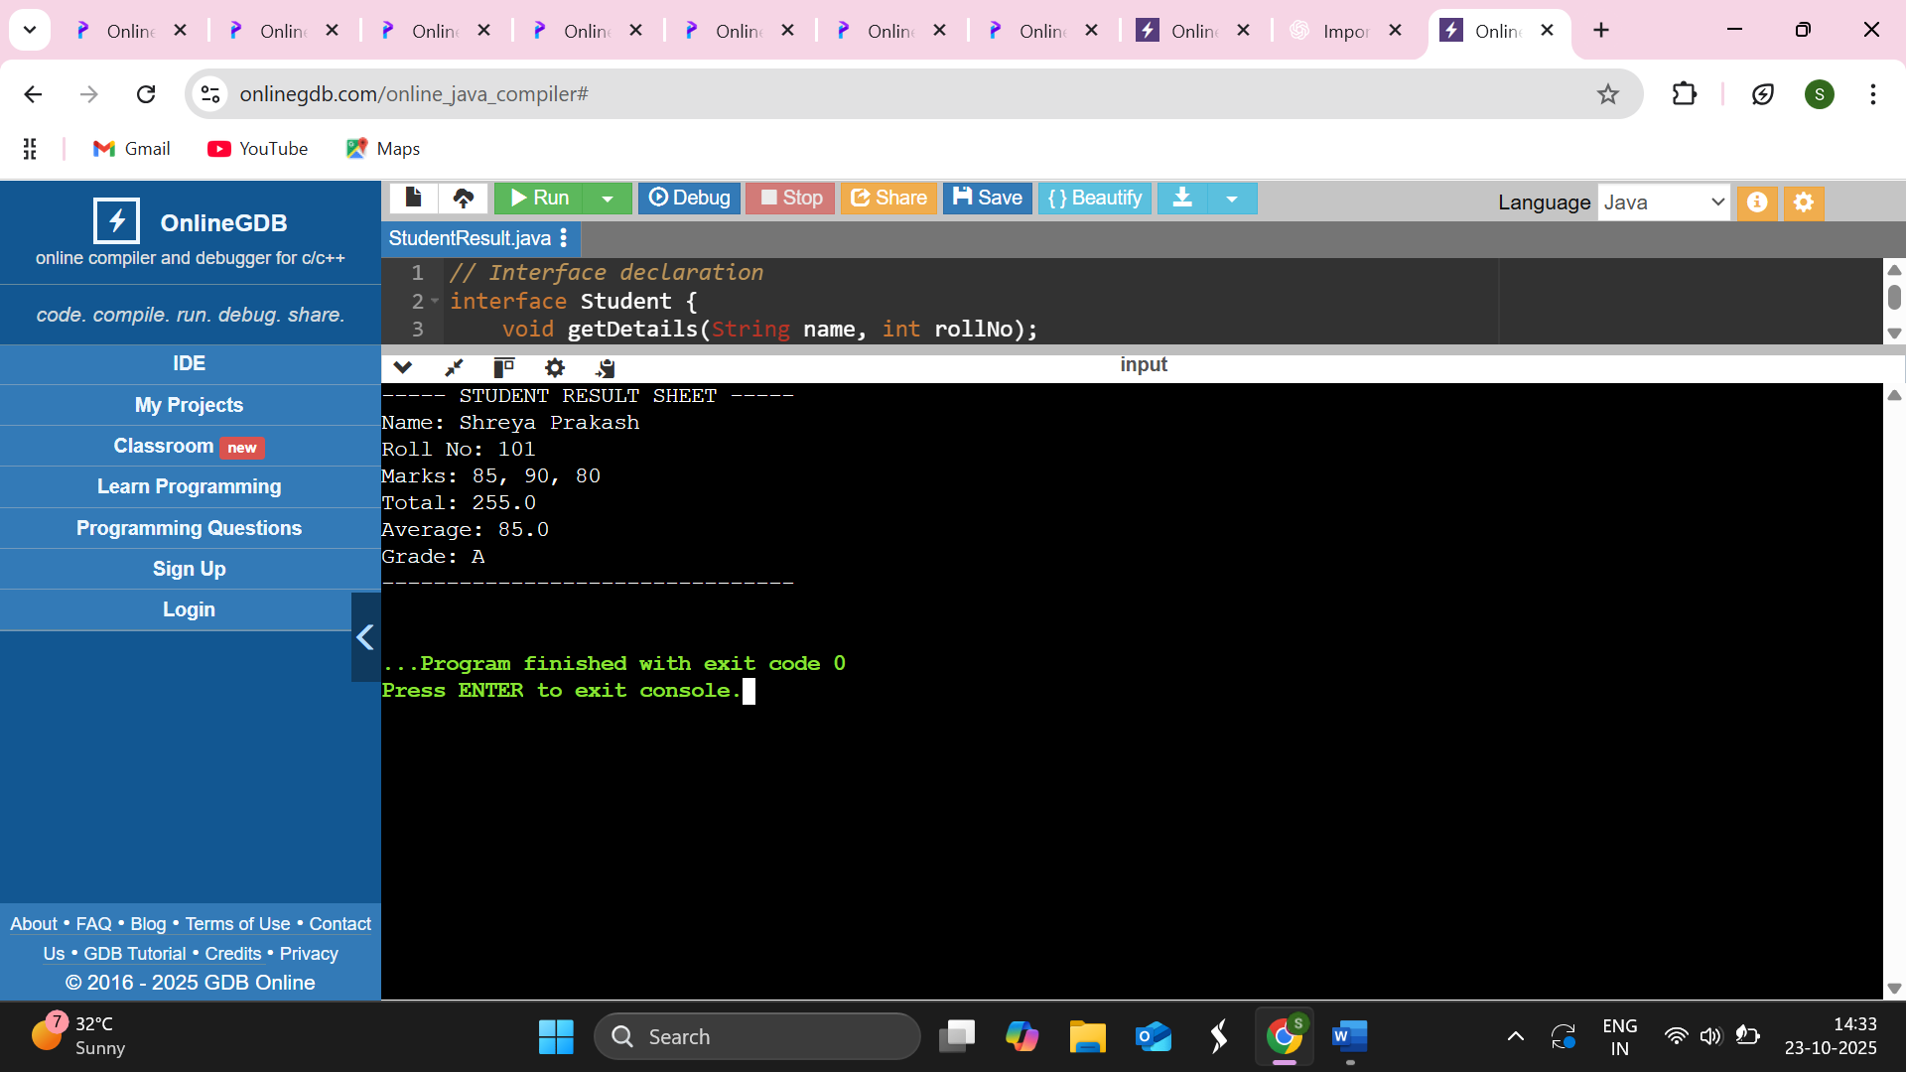

18.Write a Java program which shows importing of classes from other packages.
Source code
package package1;
public class Message {
public void showMessage() {
System.out.println("Hello from package1!");
}
}
package package2;
import package1.Message;
public class DisplayMessage {
public static void main(String[] args) {
Message msg = new Message();
msg.showMessage();
}
}
Output

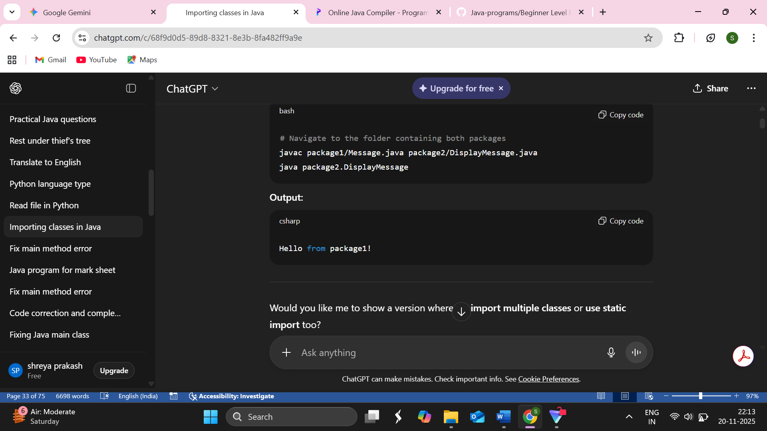

19.Assume that there are two packages, student and exam. A student package contains student class and the exam package contains result class. Write a Java program that generates mark sheet for student.
Source code
public class MarksheetProgram {
public static class Student {
private String name;
private int rollNo;
public Student(String name, int rollNo) {
this.name = name;
this.rollNo = rollNo;
}
public String getName() {
return name;
}
public int getRollNo() {
return rollNo;
}
}
public static class Result {
private Student student;
private int m1, m2, m3;
public Result(Student student, int m1, int m2, int m3) {
this.student = student;
this.m1 = m1;
this.m2 = m2;
this.m3 = m3;
}
public void displayMarksheet() {
int total = m1 + m2 + m3;
double percentage = total / 3.0;
System.out.println("----- STUDENT MARK SHEET -----");
System.out.println("Name : " + student.getName());
System.out.println("Roll No : " + student.getRollNo());
System.out.println("Marks 1 : " + m1);
System.out.println("Marks 2 : " + m2);
System.out.println("Marks 3 : " + m3);
System.out.println("-------------------------------");
System.out.println("Total : " + total);
System.out.println("Percentage : " + percentage + "%");
System.out.println("-------------------------------");

if (percentage >= 60)
System.out.println("Division : First Division");
else if (percentage >= 45)
System.out.println("Division : Second Division");
else if (percentage >= 33)
System.out.println("Division : Third Division");
else
System.out.println("Division : Fail");
}
}
public static void main(String[] args) {
Student s1 = new Student("Shreya", 101);
Result r1 = new Result(s1, 85, 78, 90);
r1.displayMarksheet();
}
}
Output
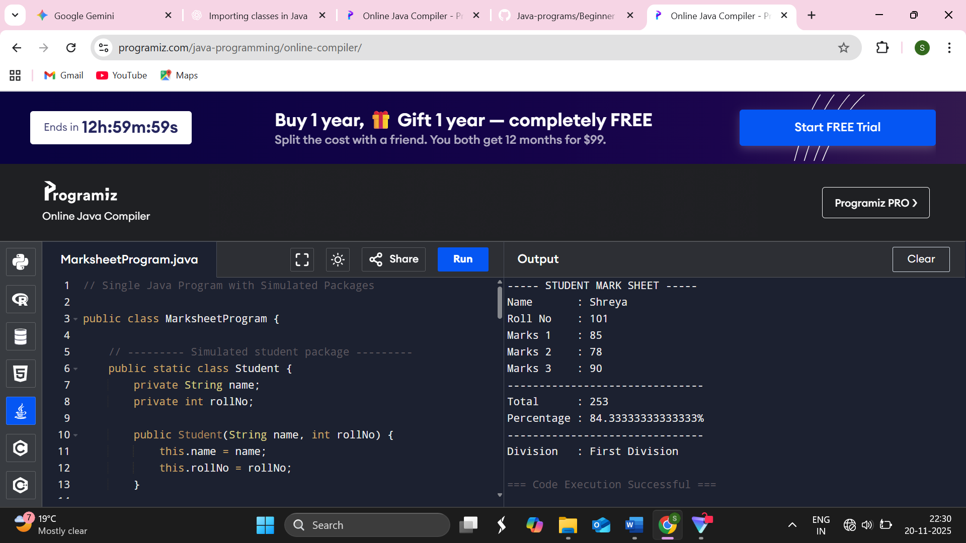
20.We write a Java program to implement the concept of threading by implementing runnable interfaces.
Source code
class MyThread implements Runnable {
private String threadName;
MyThread(String name) {
threadName = name;
}
public void run() {
System.out.println(threadName + " is starting...");
try {
for (int i = 1; i <= 5; i++) {
System.out.println(threadName + " - Count: " + i);
Thread.sleep(1000);
}
} catch (InterruptedException e) {
System.out.println(threadName + " interrupted.");
}
System.out.println(threadName + " has finished execution.");
}
}
public class RunnableDemo {
public static void main(String[] args) {
MyThread t1 = new MyThread("Thread 1");
MyThread t2 = new MyThread("Thread 2");
Thread thread1 = new Thread(t1);
Thread thread2 = new Thread(t2);
thread1.start();
thread2.start();
System.out.println("Main thread is running...");
}
}
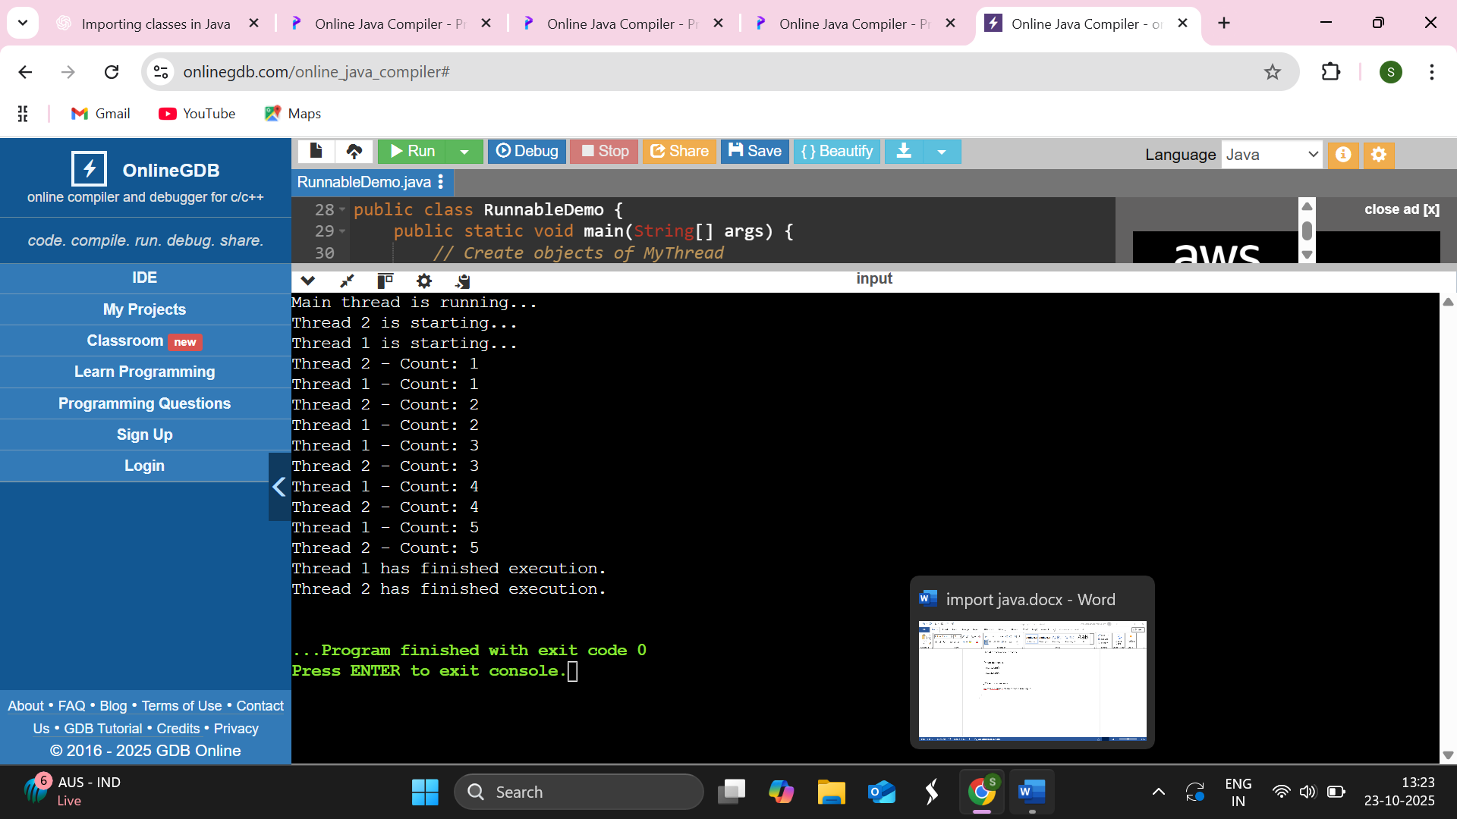

21.Write a Java program that executes two threads, one thread displays thread 1 every 2,000 milliseconds and the other displays thread 2 every 4,000 milliseconds.
Source code
class MyThread implements Runnable {
private String threadName;
private int delay;
MyThread(String name, int delay) {
this.threadName = name;
this.delay = delay;
}
public void run() {
try {
while (true) {
System.out.println(threadName + " is running");
Thread.sleep(delay);
}
} catch (InterruptedException e) {
System.out.println(threadName + " interrupted.");
}
}
}
public class ThreadIntervalDemo {
public static void main(String[] args) {
MyThread t1 = new MyThread("Thread 1", 2000);
MyThread t2 = new MyThread("Thread 2", 4000);
Thread thread1 = new Thread(t1);
Thread thread2 = new Thread(t2);
thread1.start();
thread2.start();
}
}
Output
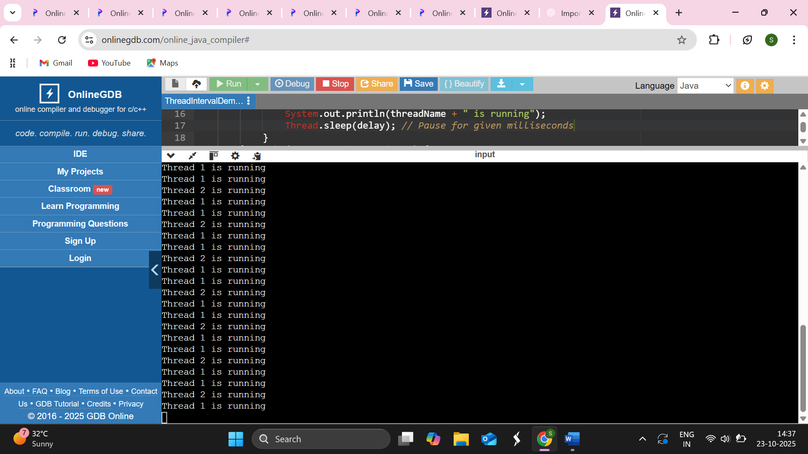

22.Write a Java program which use try and catch for exception handling.
Source code
import java.util.Scanner;
public class ExceptionExample {
public static void main(String[] args) {
Scanner sc = new Scanner(System.in);
try{
System.out.print("Enter first number: ");
int num1 = sc.nextInt();
System.out.print("Enter second number: ");
int num2 = sc.nextInt();
int result = num1 / num2; // May cause ArithmeticException
System.out.println("Result: " + result);
}
catch (ArithmeticException e) {
System.out.println("Error: Division by zero is not allowed!");
}
catch (Exception e) {
System.out.println("An unexpected error occurred: " + e);
}
finally {
System.out.println("Execution completed. (finally block executed)");
sc.close();
}
}
}
Output
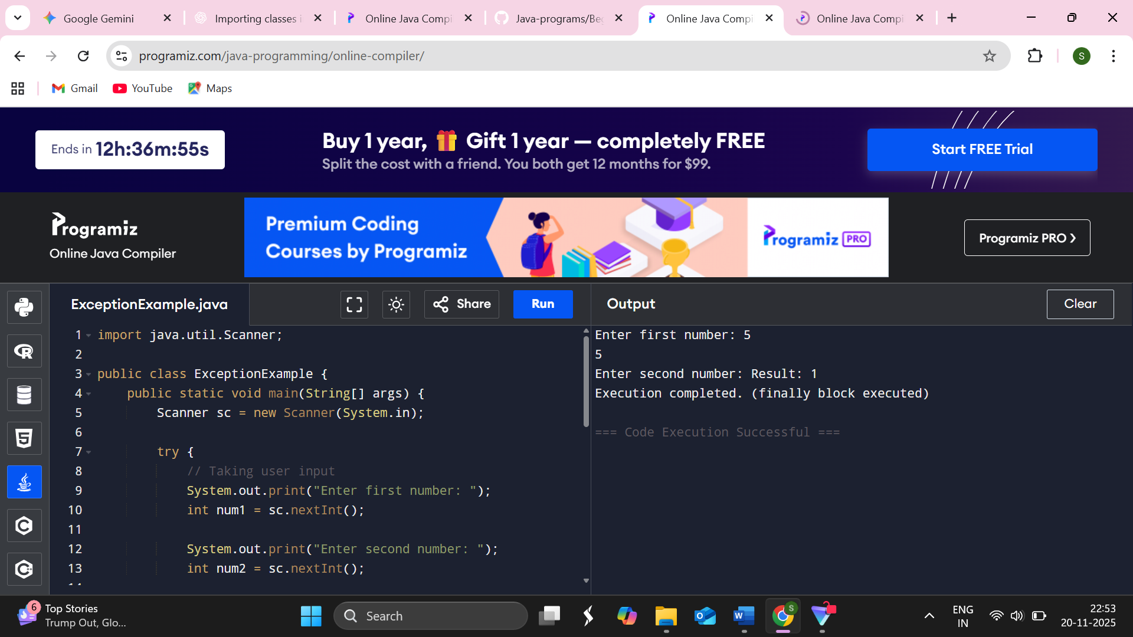
23.Write a program that use multiple catch block
Source code
public class MultipleCatchDemo {
public static void main(String[] args) {
try {
int a = 10, b = 0;
int result = a / b;
System.out.println("Result: " + result);
int arr[] = {1, 2, 3};
System.out.println(arr[5]);
String str = null;
System.out.println(str.length());
}
catch (ArithmeticException e) {
System.out.println("Arithmetic Exception Occurred: " + e.getMessage());
}
catch (ArrayIndexOutOfBoundsException e) {
System.out.println("Array Index Out Of Bounds: " + e.getMessage());
}
catch (NullPointerException e) {
System.out.println("Null Pointer Exception: " + e.getMessage());
}
catch (Exception e) {
System.out.println("General Exception Caught: " + e.getMessage());
}
System.out.println("Program continues normally...");
}
}
Output
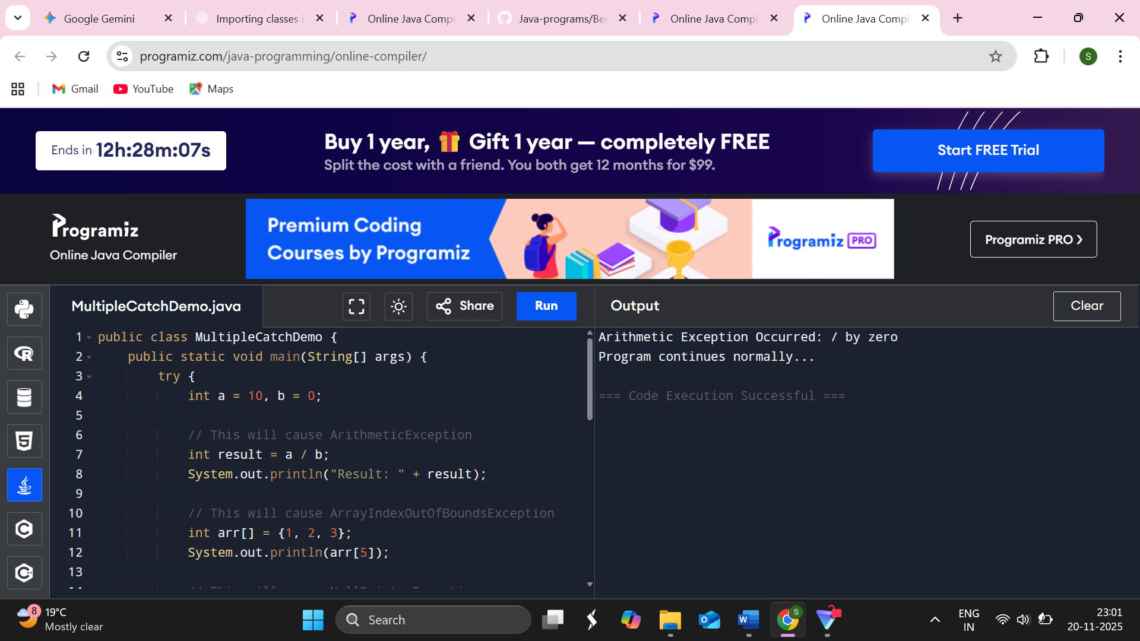

24.Write a Java program which shows throwing our own exception.
Source code
class InvalidAgeException extends Exception {
public InvalidAgeException(String message) {
super(message);
}
}
public class CustomExceptionDemo{
static void checkAge(int age) throws InvalidAgeException {
if (age < 18) {
throw new InvalidAgeException("Age below 18 is not allowed to vote!");
} else {
System.out.println("Eligible to vote!");
}
}
public static void main(String[] args) {
try{
checkAge(15);
}
catch (InvalidAgeException e) {
System.out.println("Caught Exception: " + e.getMessage());
}
finally {
System.out.println("Program execution completed.");
}
}
}
Output
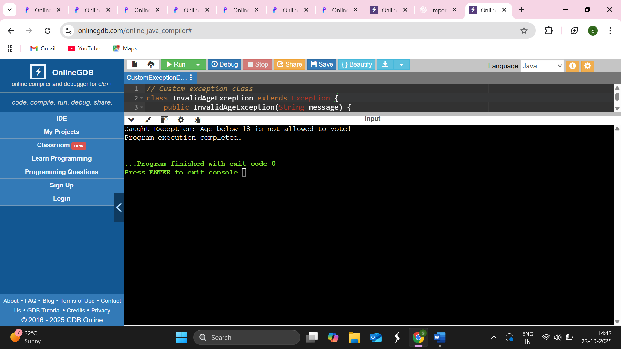

25.Write a Java program to handle labels and buttons using AWT controls.
Source code
import java.awt.*;
import java.awt.event.*;
public class LabelButtonDemo extends Frame implements ActionListener {
Label messageLabel;
Button clickButton, exitButton;
public LabelButtonDemo() {
setTitle("AWT Label and Button Example");
setSize(400, 300);
setLayout(null);
messageLabel = new Label("Click a button");
messageLabel.setBounds(50, 50, 300, 30);
add(messageLabel);
clickButton = new Button("Click Me");
clickButton.setBounds(50, 100, 80, 30);
add(clickButton);
exitButton = new Button("Exit");
exitButton.setBounds(150, 100, 80, 30);
add(exitButton);
clickButton.addActionListener(this);
exitButton.addActionListener(this);
addWindowListener(new WindowAdapter() {
public void windowClosing(WindowEvent we) {
System.exit(0);
}
});
setVisible(true);
}
public void actionPerformed(ActionEvent e) {
if (e.getSource() == clickButton) {
messageLabel.setText("You clicked the Click Me button!");
} else if (e.getSource() == exitButton) {
System.exit(0);
}
}
public static void main(String[] args) {
new LabelButtonDemo();
}
}
Output
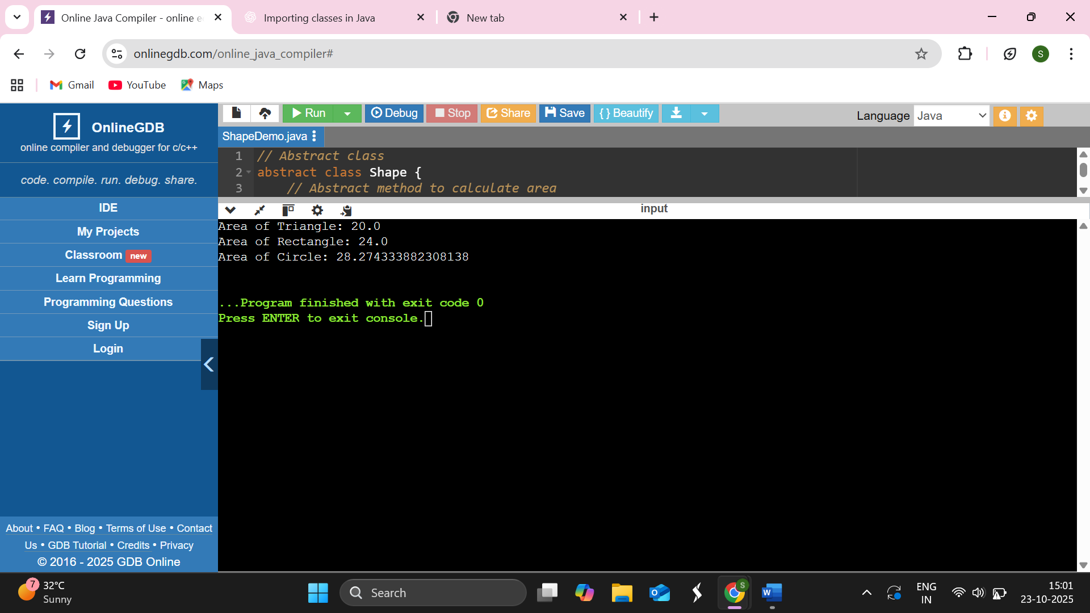

26.Write a Java program to handle check boxes using AWT controls.
Source code
import java.awt.*;
import java.awt.event.*;
public class CheckboxDemo extends Frame implements ItemListener, ActionListener {
Checkbox cb1, cb2, cb3;
Label selectedLabel;
Button exitButton;
public CheckboxDemo()
setTitle("AWT Checkbox Example");
setSize(400, 300);
setLayout(null);
cb1 = new Checkbox("Java");
cb2 = new Checkbox("Python");
cb3 = new Checkbox("C++");
cb1.setBounds(50, 50, 100, 30);
cb2.setBounds(50, 80, 100, 30);
cb3.setBounds(50, 110, 100, 30);
add(cb1);
add(cb2);
add(cb3);
selectedLabel = new Label("Selected Languages: ");
selectedLabel.setBounds(50, 150, 300, 30);
add(selectedLabel);
exitButton = new Button("Exit");
exitButton.setBounds(150, 200, 80, 30);
add(exitButton);
cb1.addItemListener(this);
cb2.addItemListener(this);
cb3.addItemListener(this);
exitButton.addActionListener(this);
addWindowListener(new WindowAdapter() {
public void windowClosing(WindowEvent we) {
System.exit(0);
}
});
setVisible(true);
}
public void itemStateChanged(ItemEvent e) {
String selected = ""
if (cb1.getState()) selected += "Java ";
if (cb2.getState()) selected += "Python ";
if (cb3.getState()) selected += "C++ ";
selectedLabel.setText("Selected Languages: " + selected);
}
public void actionPerformed(ActionEvent e) {
if (e.getSource() == exitButton) {
System.exit(0);
}
}
public static void main(String[] args) {
new CheckboxDemo();
}
}
Output
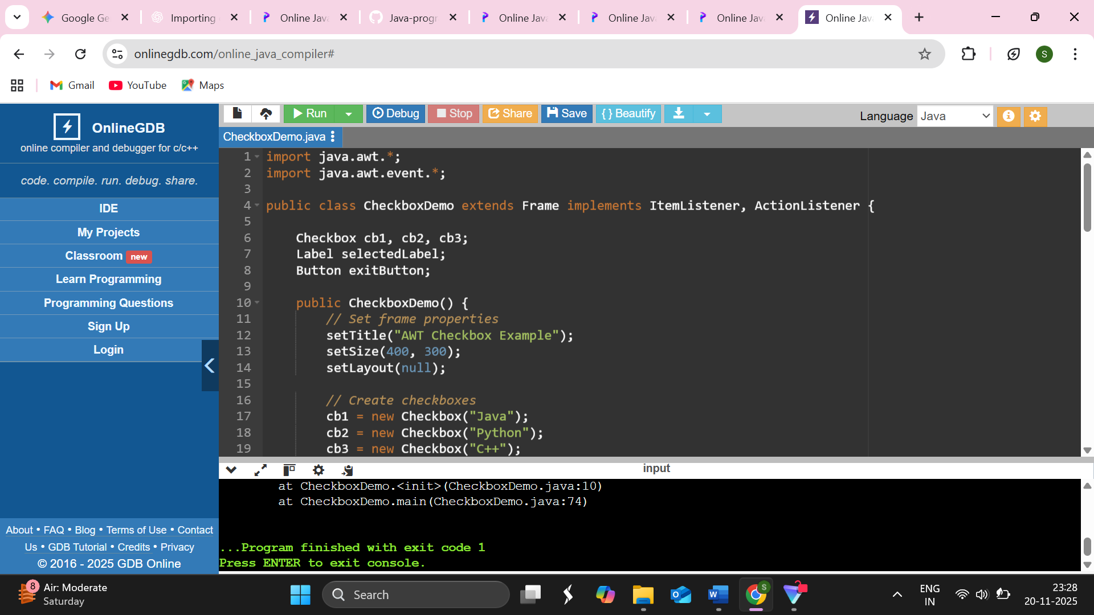

27.Write a Java program to handle lists and scroll bars using AWT controls.
Source code
import java.awt.*;
import java.awt.event.*;
public class ListScrollbarDemo extends Frame implements AdjustmentListener, ActionListener {
List cityList;
Scrollbar redScroll, greenScroll, blueScroll;
Label colorLabel, cityLabel;
Button exitButton;
Color bgColor;
public ListScrollbarDemo() {
setTitle("AWT List and Scrollbar Example");
setLayout(null);
setSize(400, 400);
cityList = new List(5, false);
cityList.add("New York");
cityList.add("London");
cityList.add("Tokyo");
cityList.add("Delhi");
cityList.add("Paris");
cityList.setBounds(50, 50, 120, 100);
add(cityList);
redScroll = new Scrollbar(Scrollbar.HORIZONTAL, 0, 1, 0, 256);
greenScroll = new Scrollbar(Scrollbar.HORIZONTAL, 0, 1, 0, 256);
blueScroll = new Scrollbar(Scrollbar.HORIZONTAL, 0, 1, 0, 256);
redScroll.setBounds(50, 180, 300, 20);
greenScroll.setBounds(50, 210, 300, 20);
blueScroll.setBounds(50, 240, 300, 20);
add(redScroll);
add(greenScroll);
add(blueScroll);
cityLabel = new Label("Select a City:");
cityLabel.setBounds(50, 30, 150, 20);
add(cityLabel);
colorLabel = new Label("Adjust background color using scrollbars");
colorLabel.setBounds(50, 270, 300, 20);
add(colorLabel);
exitButton = new Button("Exit");
exitButton.setBounds(150, 320, 80, 30);
add(exitButton);
redScroll.addAdjustmentListener(this);
greenScroll.addAdjustmentListener(this);
blueScroll.addAdjustmentListener(this);
exitButton.addActionListener(this);
addWindowListener(new WindowAdapter() {
public void windowClosing(WindowEvent we) {
System.exit(0);
}
});
setVisible(true);
}
public void adjustmentValueChanged(AdjustmentEvent e) {
int r = redScroll.getValue();
int g = greenScroll.getValue();
int b = blueScroll.getValue();

bgColor = new Color(r, g, b);
setBackground(bgColor);
}
public void actionPerformed(ActionEvent e) {
if (e.getSource() == exitButton) {
System.exit(0);
}
}
public static void main(String[] args) {
new ListScrollbarDemo();
}
}
